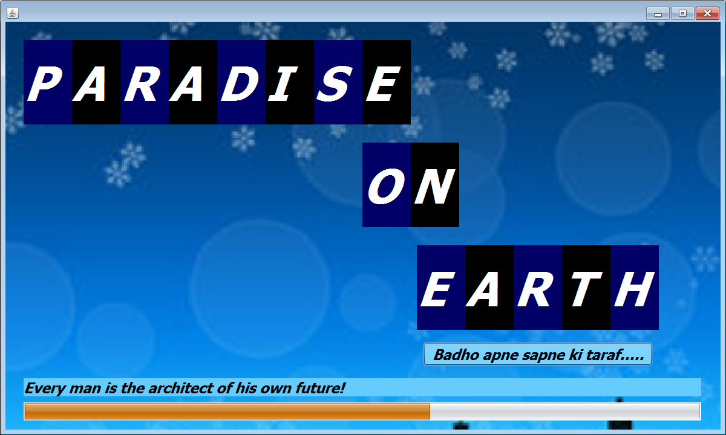

import javax.swing.Timer;

import java.awt.event.*;

import javax.swing.ImageIcon;

public class Frame1 extends javax.swing.JFrame {int i,j;

int a;

Timer tom=new Timer(100,new ActionListener(){

public void actionPerformed(ActionEvent e){

a++;

if(a==1){ p1.setVisible(true); }

if(a==2){ p5.setVisible(true); }

if(a==3){ p4.setVisible(true); }

if(a==4){ p6.setVisible(true); }

if(a==5){ p7.setVisible(true); }

if(a==6){ p9.setVisible(true); }

if(a==7){ p10.setVisible(true); }

if(a==8){ p11.setVisible(true); }

if(a==9){ p12.setVisible(true); }

if(a==10){ p13.setVisible(true); }

if(a==11){ p14.setVisible(true); }

if(a==12){ p15.setVisible(true);}

if(a==13){ p16.setVisible(true);}

if(a==14){ p17.setVisible(true); }

if(a==15){ p8.setVisible(true); }

if(a==16){ b1.setVisible(true);}

}});

Timer tm=new Timer(150,new ActionListener(){

public void actionPerformed(ActionEvent e){

int i=l1.getValue();

l1.setValue(i+5);

lq.setVisible(true);

l1.setVisible(true);

lp.setText(""+i);

if(lp.getText().equals("0")){

lq.setText("I've never lived in a building without my name on it......"); }

if(lp.getText().equals("25")){

lq.setText("Ghar ek sapna isko banalo apna!"); }

if(lp.getText().equals("50")){

lq.setText("Every man is the architect of his own future!"); }

if(lp.getText().equals("75")){

lq.setText("We carry our homes within us which enable us to fly!"); }

if (lp.getText().equals("100")){

tm.stop();

bhk1.setVisible(true); }

}});

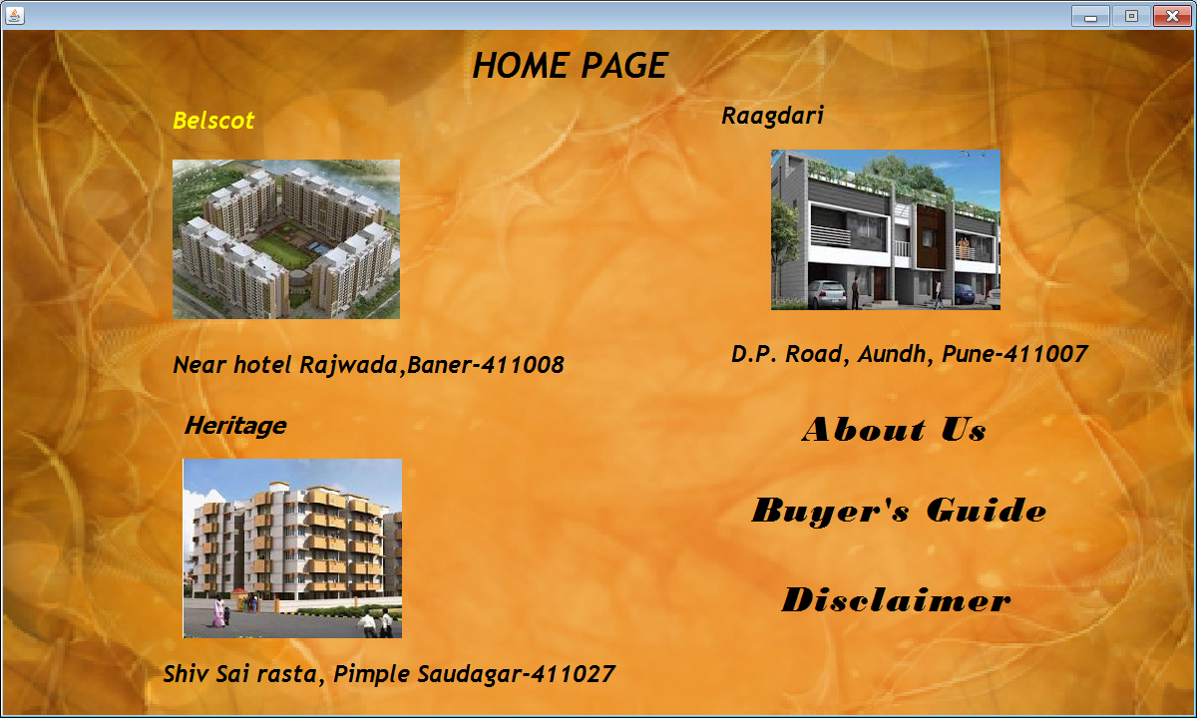

**Belscot**

private void bhkbMouseEntered(java.awt.event.MouseEvent evt) {

bhkb.setVisible(false);

bhka.setVisible(true); }

private void bhkbMouseExited(java.awt.event.MouseEvent evt) {

bhkb.setVisible(true);

bhka.setVisible(false); }

private void f1MouseEntered(java.awt.event.MouseEvent evt) {

f1.setForeground(Color.yellow); }

private void f1MouseExited(java.awt.event.MouseEvent evt) {

f1.setForeground(Color.black); }

private void f1MouseClicked(java.awt.event.MouseEvent evt) {

belscot1.setVisible(true);

bhk1.setVisible(false); }

**Raagdari**

private void f4rMouseEntered(java.awt.event.MouseEvent evt) {

f4r.setVisible(false);

f4r1.setVisible(true);}

private void f4r1MouseExited(java.awt.event.MouseEvent evt) {

f4r1.setVisible(false);

f4r.setVisible(true); }

private void f60MouseEntered(java.awt.event.MouseEvent evt) {

f60.setForeground(Color.yellow); }

private void f60MouseExited(java.awt.event.MouseEvent evt) {

f60.setForeground(Color.black); }

private void f60MouseClicked(java.awt.event.MouseEvent evt) {

rgd1.setVisible(true);bhk1.setVisible(false); }

**Heritage**

private void f22MouseEntered(java.awt.event.MouseEvent evt) {

f22.setVisible(false);

f23.setVisible(true); }

private void f22MouseExited(java.awt.event.MouseEvent evt) {

f22.setVisible(true);

f23.setVisible(false); }

private void f21MouseEntered(java.awt.event.MouseEvent evt) {

f21.setForeground(Color.yellow); }

private void f21MouseExited(java.awt.event.MouseEvent evt) {

f21.setForeground(Color.black); }

private void f21MouseClicked(java.awt.event.MouseEvent evt) {

heritage.setVisible(true);bhk1.setVisible(false); }

**About us**

private void abtusMouseClicked(java.awt.event.MouseEvent evt) {

f_abtus.setVisible(true);bhk1.setVisible(false); }

private void abtusMouseEntered(java.awt.event.MouseEvent evt) {

abtus.setForeground(Color.yellow); }

private void abtusMouseExited(java.awt.event.MouseEvent evt) {

abtus.setForeground(Color.black); }

**Buyer’s Guide**

private void bgMouseClicked(java.awt.event.MouseEvent evt) {

f_bguide.setVisible(true);bhk1.setVisible(false); }

private void bgMouseEntered(java.awt.event.MouseEvent evt) {

bg.setForeground(Color.yellow); }

private void bgMouseExited(java.awt.event.MouseEvent evt) {

bg.setForeground(Color.black); }

**Disclaimer**

private void discMouseClicked(java.awt.event.MouseEvent evt) {

f_dclm.setVisible(true);

bhk1.setVisible(false); }

private void discMouseEntered(java.awt.event.MouseEvent evt) {

disc.setForeground(Color.yellow); }

private void discMouseExited(java.awt.event.MouseEvent evt) {

disc.setForeground(Color.black); }



**Back Button**

private void jLabel2MouseClicked(java.awt.event.MouseEvent evt) {

bhk1.setVisible(true);

f_abtus.setVisible(false); }

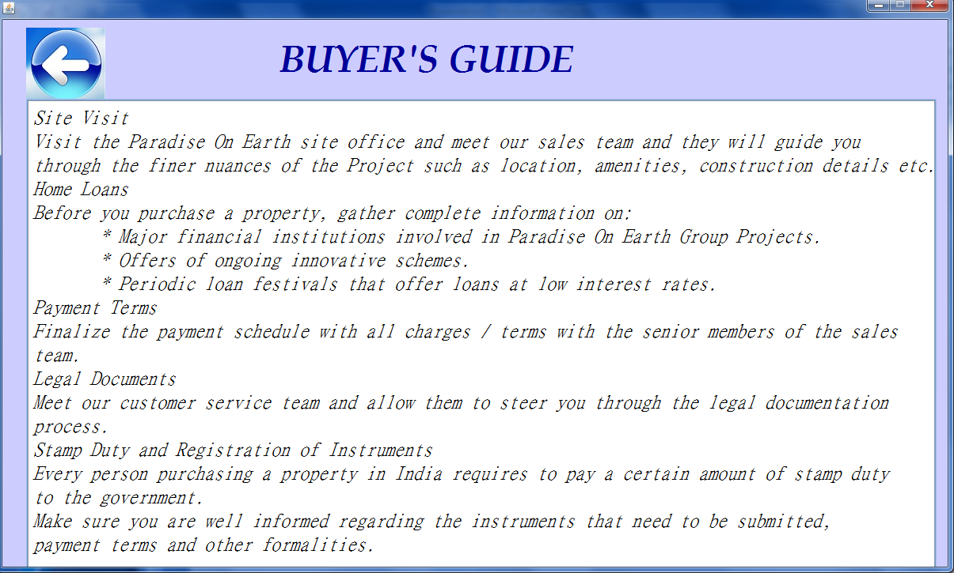

**Back Button**

private void jLabel124MouseClicked(java.awt.event.MouseEvent evt) {

bhk1.setVisible(true);

f_bguide.setVisible(false);}

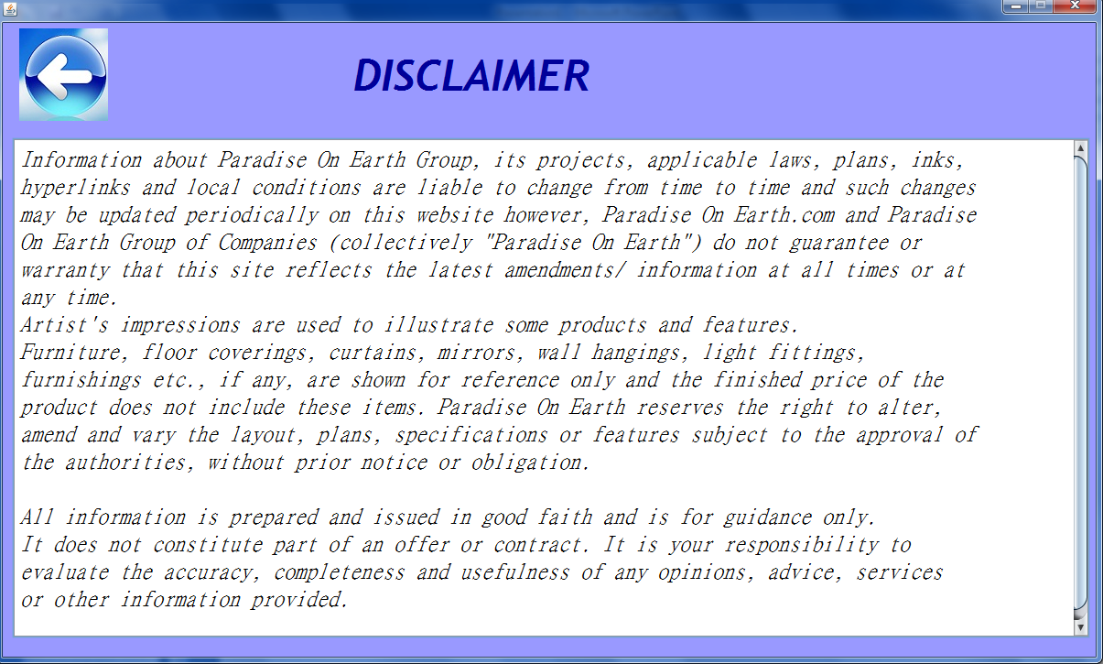

**Back Button**

private void jLabel16MouseClicked(java.awt.event.MouseEvent evt) {

bhk1.setVisible(true);

f_dclm.setVisible(false); }

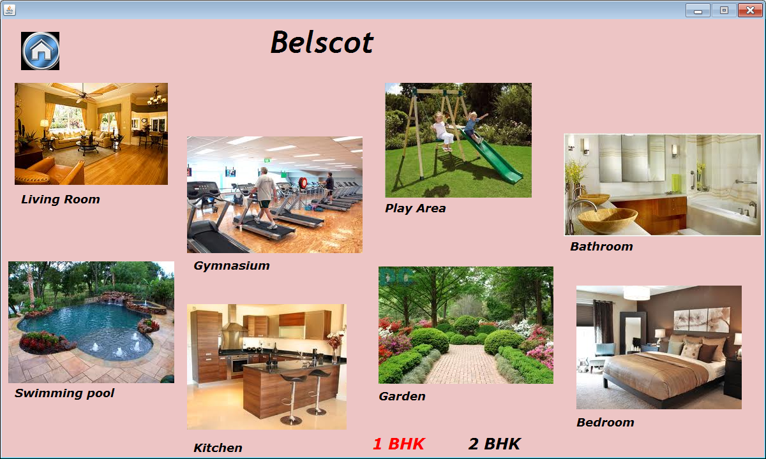

import javax.swing.ImageIcon;

**Back Button**

private void jLabel125MouseClicked(java.awt.event.MouseEvent evt) {

bhk1.setVisible(true); }

**1 BHK Label**

private void jLabel43MouseClicked(java.awt.event.MouseEvent evt) {

bhk1_a.setVisible(true);belscot1.setVisible(false); }

private void jLabel43MouseEntered(java.awt.event.MouseEvent evt) {

jLabel43.setForeground(Color.red); }

private void jLabel43MouseExited(java.awt.event.MouseEvent evt) {

jLabel43.setForeground(Color.black); }

**2 BHK Label**

private void jLabel44MouseClicked(java.awt.event.MouseEvent evt) {

bhk2_a.setVisible(true);belscot1.setVisible(false); }

private void jLabel44MouseEntered(java.awt.event.MouseEvent evt) {

jLabel44.setForeground(Color.red); }

private void jLabel44MouseExited(java.awt.event.MouseEvent evt) {

jLabel44.setForeground(Color.black); }

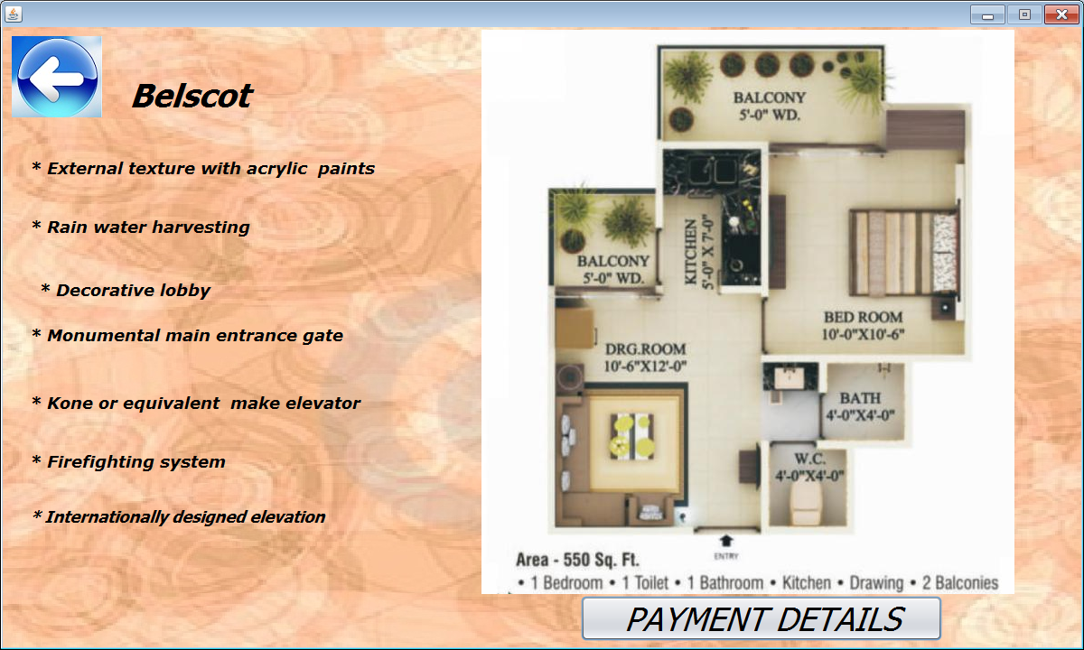

**Back Button**

private void jLabel126MouseClicked(java.awt.event.MouseEvent evt) {

belscot1.setVisible(true);

bhk1.setVisible(false);

}

**Payment Details Button**

private void jButton3ActionPerformed(java.awt.event.ActionEvent evt) {

bhk1_b.setVisible(true);

bhk1_a.setVisible(false);

}

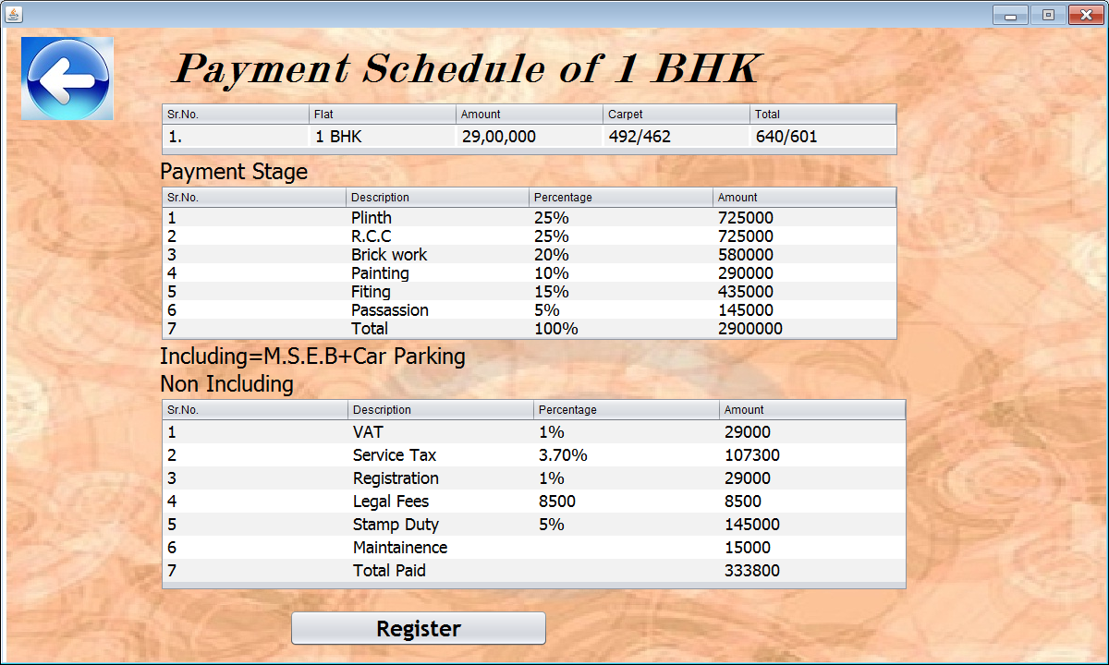

**Back Button**

private void jLabel123MouseClicked(java.awt.event.MouseEvent evt) {

bhk1_a.setVisible(true);

bhk1_b.setVisible(false);

}

**Register Button**

private void jButton4ActionPerformed(java.awt.event.ActionEvent evt) {

f_signin.setVisible(true);

t1.setText("");

t2.setText("");

t5.setText("");

t6.setText("");

t3.setSelected(false);

t4.setSelected(false);

}

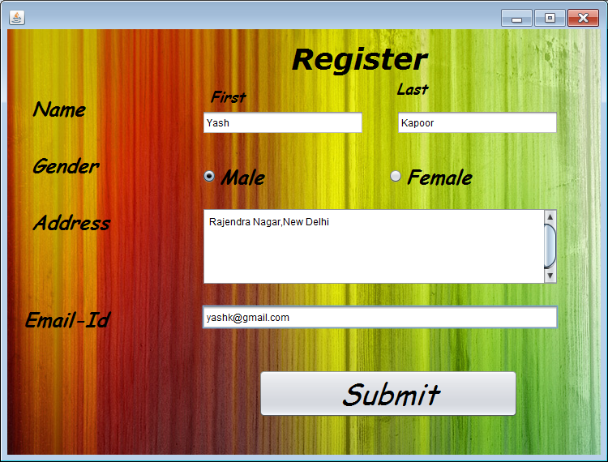

Connection con=null;

ResultSet rs=null;

Statement st=null;

private void jButton7ActionPerformed(java.awt.event.ActionEvent evt) {

String b=t1.getText();

String c=t2.getText();

String d=t5.getText();

String f=t6.getText();

if (b.equals("")){

JOptionPane.showMessageDialog(null,"Please fill all the details");}

else

if (c.equals("")){

JOptionPane.showMessageDialog(null,"Please fill all the details");}

else

if (d.equals("")){

JOptionPane.showMessageDialog(null,"Please fill all the details");}

else

if (f.equals("")){

JOptionPane.showMessageDialog(null,"Please fill all the details");}

else

if(t3.isSelected()==false & t4.isSelected()==false){JOptionPane.showMessageDialog(null,"Please fill all the details");}

else{

try{

String qri=null;

if(t3.isSelected()==true){

qri="insert into signin values('"+b+"','"+c+"','M','"+d+"','"+f+"');"; }

if(t4.isSelected()==true){

qri="insert into signin values('"+b+"','"+c+"','F','"+d+"','"+f+"');"; }

Class.forName("java.sql.Driver");

con=DriverManager.getConnection("jdbc:mysql://localhost/pro","root","1234");

st=con.createStatement();

st.executeUpdate(qri); }

catch(Exception e) {

System.out.println(e); }

dialog.setVisible(true); }}

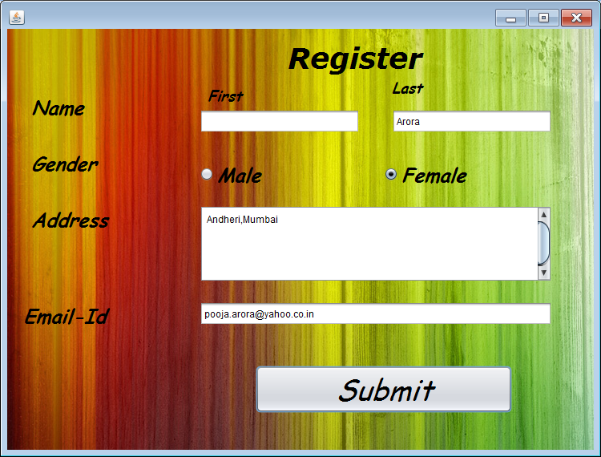

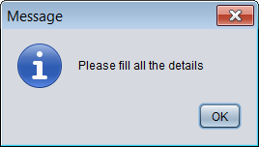

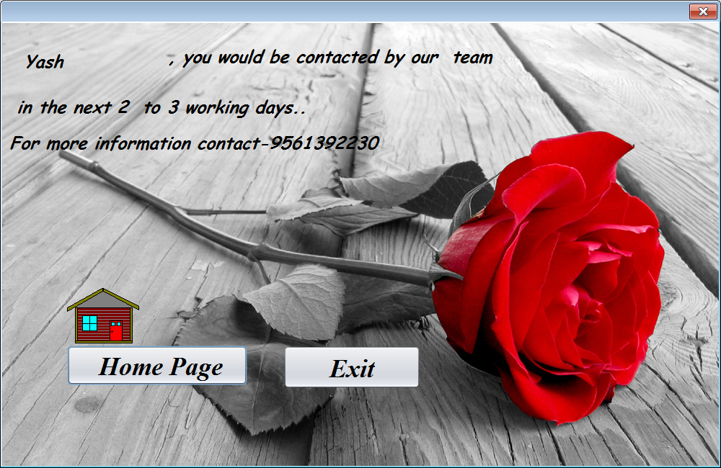

**Home Page**

private void jButton9ActionPerformed(java.awt.event.ActionEvent evt) {

bhk1.setVisible(true);

dialog.setVisible(false); }

**Exit**

private void jButton1ActionPerformed(java.awt.event.ActionEvent evt) {

System.exit(0);

}

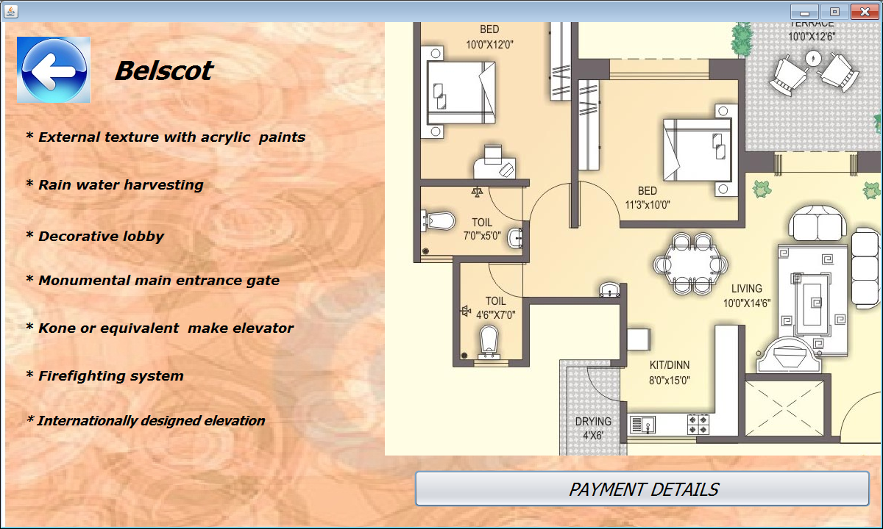

**Back Button**

private void jLabel127MouseClicked(java.awt.event.MouseEvent evt) {

belscot1.setVisible(true);

bhk1.setVisible(false);

}

**Payment Details Button**

private void jButton8ActionPerformed(java.awt.event.ActionEvent evt) {

bhk2_b.setVisible(true);

bhk2_a.setVisible(false);

}

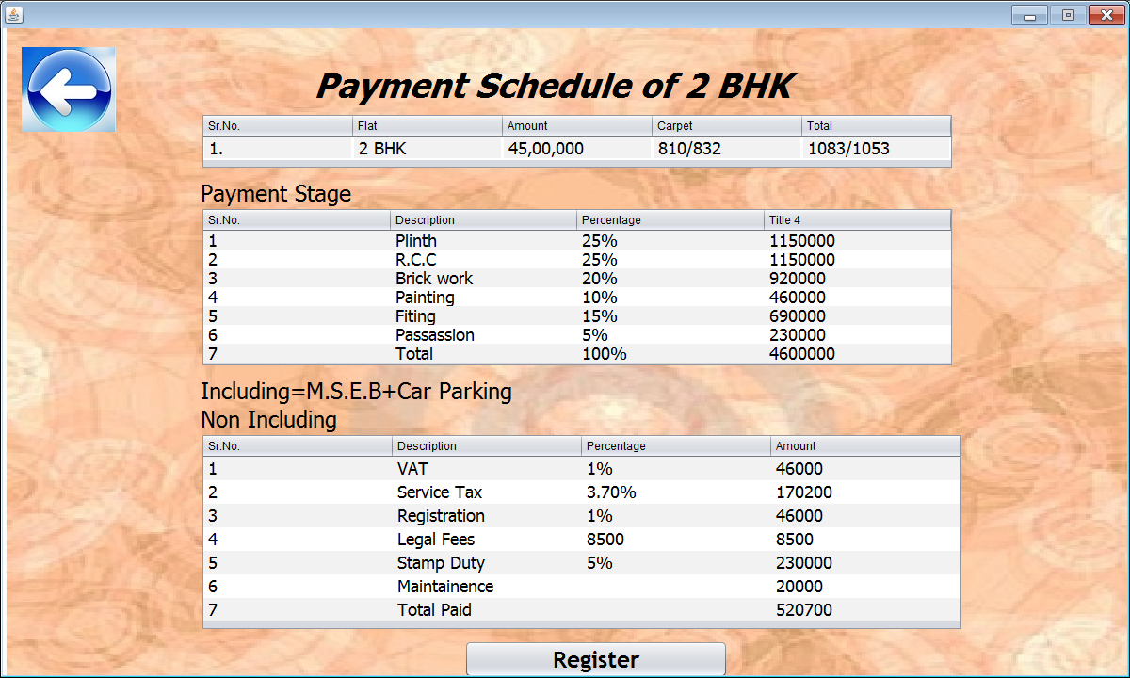

**Back Button**

private void jLabel81MouseClicked(java.awt.event.MouseEvent evt) {

bhk2_a.setVisible(true);

bhk2_b.setVisible(false); }

**Register Button**

private void jButton6ActionPerformed(java.awt.event.ActionEvent evt) {

f_signin.setVisible(true);

t1.setText("");

t2.setText("");

t5.setText("");

t6.setText("");

t3.setSelected(false);

t4.setSelected(false);

}

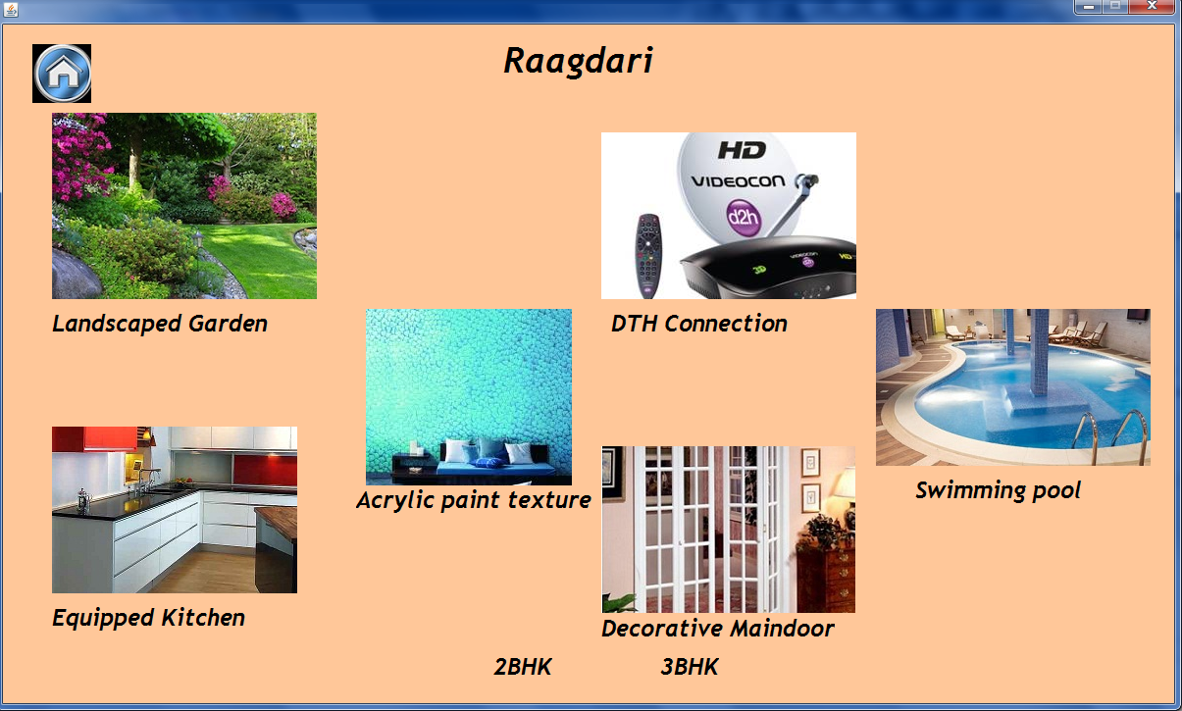

**Back Button**

private void jLabel121MouseClicked(java.awt.event.MouseEvent evt) {

bhk1.setVisible(true); }

**2 BHK Label**

private void rl1MouseClicked(java.awt.event.MouseEvent evt) {

rgd2_a.setVisible(true); rgd1.setVisible(false); }

private void rl1MouseEntered(java.awt.event.MouseEvent evt) {

rl1.setForeground(Color.blue); }

private void rl1MouseExited(java.awt.event.MouseEvent evt) {

rl1.setForeground(Color.black); }

**3 BHK Label**

private void rl2MouseClicked(java.awt.event.MouseEvent evt) {

rgd3_a.setVisible(true); rgd3_b.setVisible(false); }

private void rl2MouseEntered(java.awt.event.MouseEvent evt) {

rl2.setForeground(Color.blue); }

private void rl2MouseExited(java.awt.event.MouseEvent evt) {

rl2.setForeground(Color.black); }

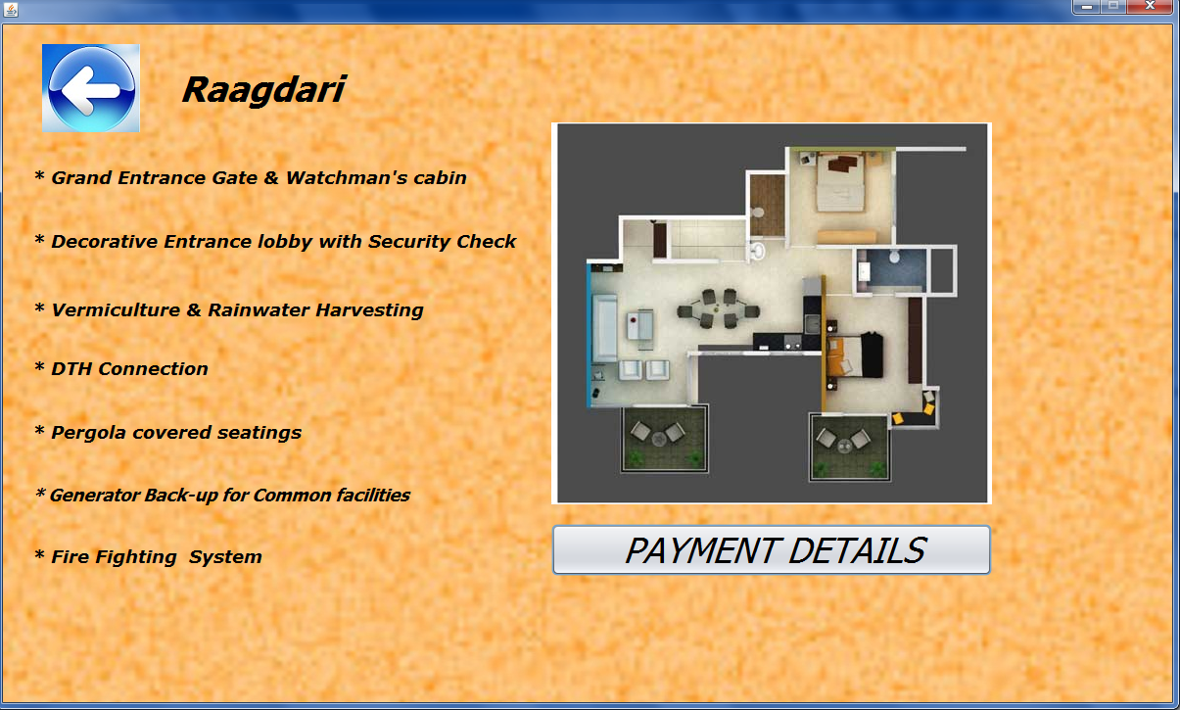

**Back Button**

private void jLabel101MouseClicked(java.awt.event.MouseEvent evt) {

rgd1.setVisible(true);

bhk1.setVisible(false);

}

**Payment Details Button**

private void jButton10ActionPerformed(java.awt.event.ActionEvent evt) {

rgd2_b.setVisible(true);

rgd2_a.setVisible(false);

}

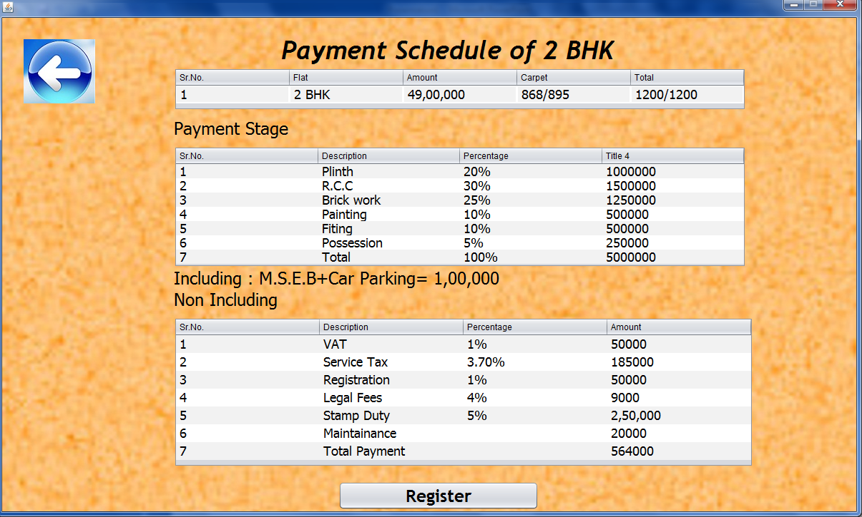**Back Button**

private void jLabel117MouseClicked(java.awt.event.MouseEvent evt) {

rgd2_a.setVisible(true);

rgd2_bsetVisible(false);

}

**Register Button**

private void jButton12ActionPerformed(java.awt.event.ActionEvent evt) {

f_signin.setVisible(true);

t1.setText("");

t2.setText("");

t5.setText("");

t6.setText("");

t3.setSelected(false);

t4.setSelected(false); }

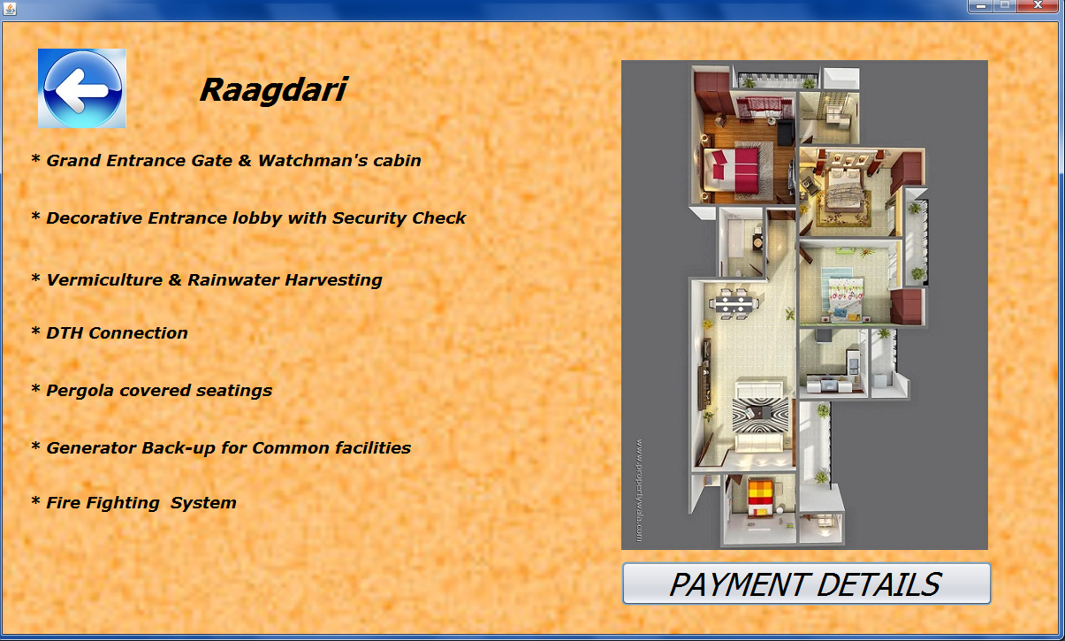

**Back Button**

private void jLabel114MouseClicked(java.awt.event.MouseEvent evt) {

rgd1.setVisible(true);

rgd3_a.setVisible(false);

}

**Payment Details Button**

private void jButton11ActionPerformed(java.awt.event.ActionEvent evt) {

rgd3_b.setVisible(true);

rgd3_a.setVisible(false);

}

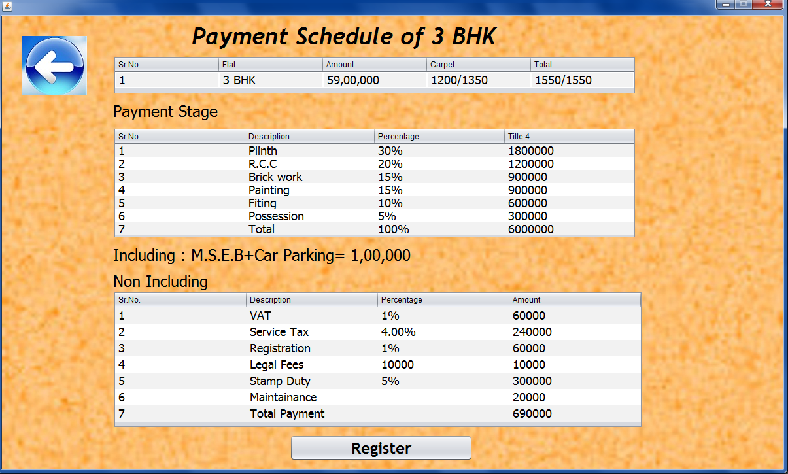

**Back Button**

private void jLabel116MouseClicked(java.awt.event.MouseEvent evt) {

rgd3_a.setVisible(true);

rgd3_b.setVisible(false);

}

**Register Button**

private void jButton13ActionPerformed(java.awt.event.ActionEvent evt) {

f_signin.setVisible(true);

t1.setText("");

t2.setText("");

t5.setText("");

t6.setText("");

t3.setSelected(false);

t4.setSelected(false);

}

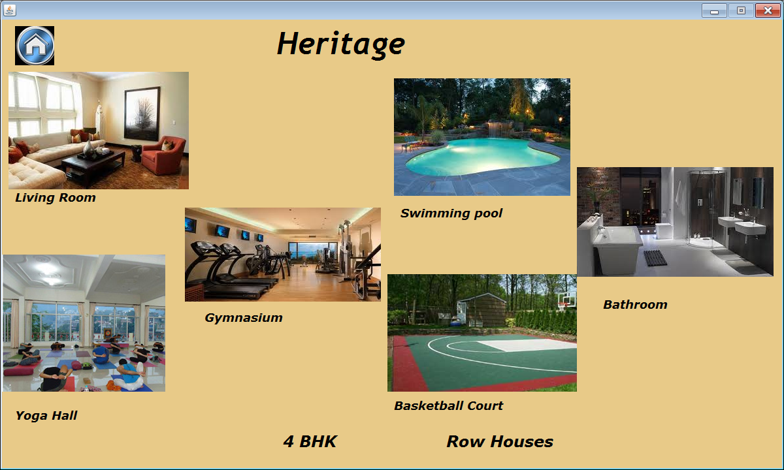

**Back Button:-**private void jLabel144MouseClicked(java.awt.event.MouseEvent evt) { bhk1.setVisible(true); heritage.setVisible(false);}

**4 BHK Label**

private void jLabel64MouseClicked(java.awt.event.MouseEvent evt) {

bhk4_a.setVisible(true);heritage.setVisible(false);}

private void jLabel64MouseEntered(java.awt.event.MouseEvent evt) {

jLabel64.setForeground(Color.blue);}

private void jLabel64MouseExited(java.awt.event.MouseEvent evt) {

jLabel64.setForeground(Color.black);}

**Row Houses Label**

private void jLabel65MouseClicked(java.awt.event.MouseEvent evt) {

rowhouse.setVisible(true);heritage.setVisible(false);}

private void jLabel65MouseEntered(java.awt.event.MouseEvent evt) {

jLabel65.setForeground(Color.blue);}

private void jLabel65MouseExited(java.awt.event.MouseEvent evt) {

jLabel65.setForeground(Color.black); }

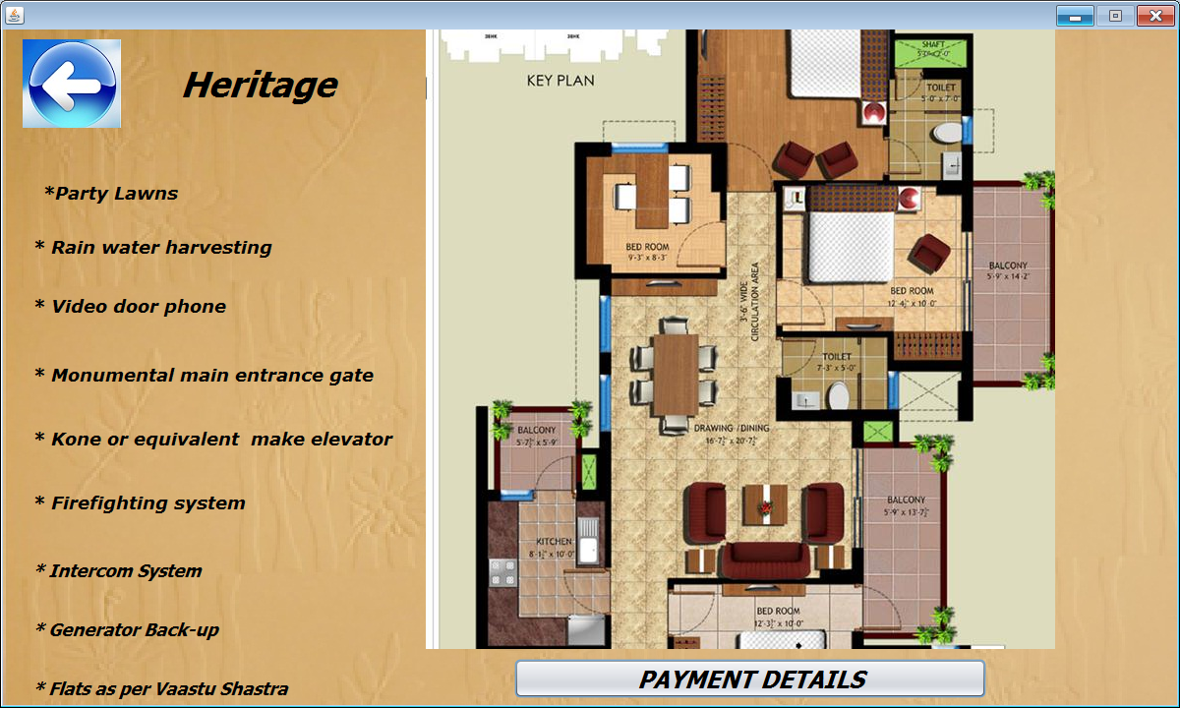

**Back Button**

private void jLabel145MouseClicked(java.awt.event.MouseEvent evt) {

heritage.setVisible(true);

bhk4_a.setVisible(false);

}

**Payment Details Button**

private void jButton15ActionPerformed(java.awt.event.ActionEvent evt) {

rate_4bk.setVisible(true);

bhk4_a.setVisible(false);

}

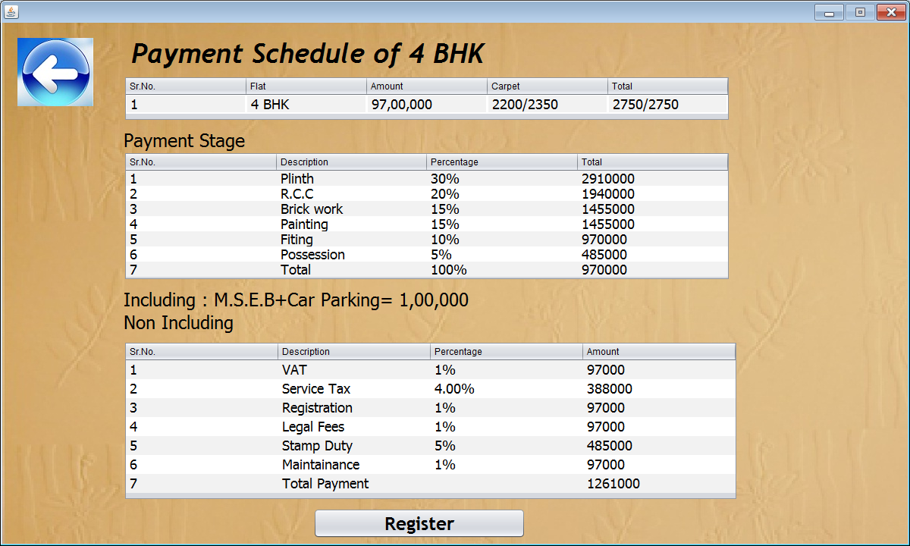

**Back Button**

private void jLabel129MouseClicked(java.awt.event.MouseEvent evt) {

heritage.setVisible(true);

rate_4bk.setVisible(false);

}

**Register Button**

private void jButton14ActionPerformed(java.awt.event.ActionEvent evt) {

f_signin.setVisible(true);

t1.setText("");

t2.setText("");

t5.setText("");

t6.setText("");

t3.setSelected(false);

t4.setSelected(false);

}

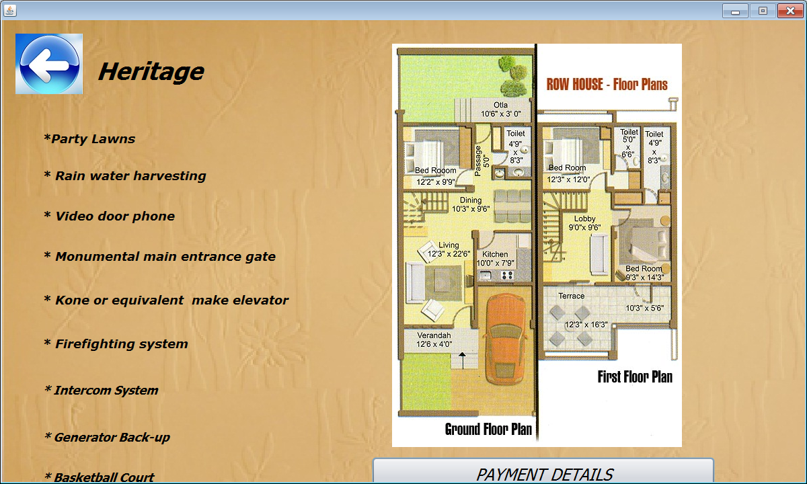

**Back Button**

private void jLabel136MouseClicked(java.awt.event.MouseEvent evt) {

heritage.setVisible(true);

rowhouse.setVisible(false);

}

**Payment Details Button**

private void jButton2ActionPerformed(java.awt.event.ActionEvent evt) {

rate_row.setVisible(true);

rowhouse.setVisible(false);

}

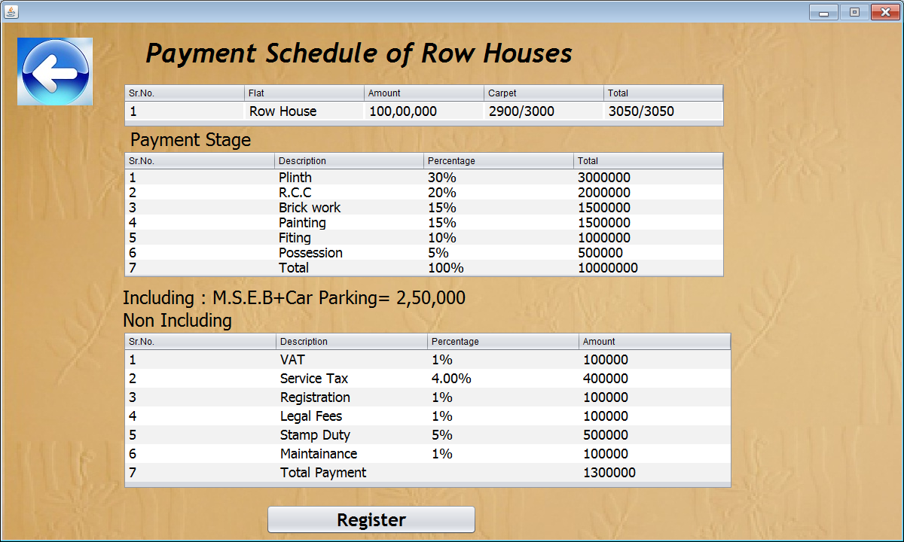

**Back Button**

private void jLabel136MouseClicked(java.awt.event.MouseEvent evt) {

rowhouse.setVisible(true);

rate_row.setVisible(false);

}

**Register Button**

private void jButton16ActionPerformed(java.awt.event.ActionEvent evt) { f_signin.setVisible(true);

t1.setText("");

t2.setText("");

t5.setText("");

t6.setText("");

t3.setSelected(false);

t4.setSelected(false);

}

**BACK END**

mysql> create database pro;

Query OK, 1 row affected (0.02 sec)

mysql> use pro;

Database changed

mysql> create table signin(

-> Fname char(15),

-> Lname char(15),

-> Gender char(1),

-> Address char(50),

-> Email_id char(20));

Query OK, 0 rows affected (0.09 sec)

mysql> select*from signin;

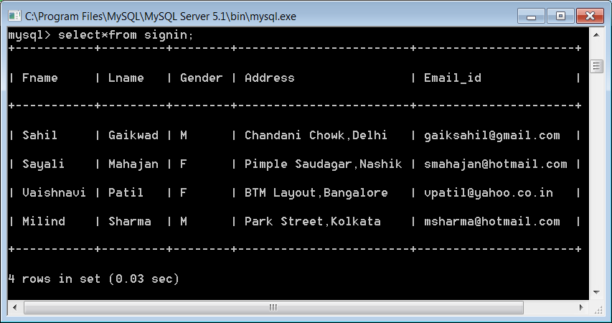

D.A.V PUBLIC SCHOOL

AUNDH,PUNE

**CERTIFICATE**

**This is to certify that**

**Miss ­­­­­­­­­­­PRAJAKTA PRAVIN KARVE**

**of class XII has completed the project with Java as Front End and Back End under supervision and guidance.**

**PRINCIPAL EX-EXAMINER IP-TEACHER**

D.A.V PUBLIC SCHOOL

AUNDH,PUNE

**CERTIFICATE**

**This is to certify that**

**Miss SAYALI SUDESH MAHAJAN**

**of class XII has completed the project with Java as Front End and Back End under supervision and guidance.**

**PRINCIPAL EX-EXAMINER IP-TEACHER**

D.A.V PUBLIC SCHOOL

AUNDH,PUNE

**CERTIFICATE**

**This is to certify that**

**Miss R.AKSHAYA**

**of class XII has completed the project with Java as Front End and Back End under supervision and guidance.**

**PRINCIPAL EX-EXAMINER IP-TEACHER**

**D.A.V PUBLIC SCHOOL**

**AUNDH,PUNE**

**INFORMATICS PRACTICES**

**PROJECT FILE**

**Name: PRAJAKTA PRAVIN KARVE**

**Class: XII**

**Board Roll No. : ________________________**

**D.A.V PUBLIC SCHOOL**

**AUNDH,PUNE**

**INFORMATICS PRACTICES**

**PROJECT FILE**

**Name: SAYALI SUDESH MAHAJAN**

**Class: XII**

**Board Roll No. : ________________________**

**D.A.V PUBLIC SCHOOL**

**AUNDH,PUNE**

**INFORMATICS PRACTICES**

**PROJECT FILE**

**Name: R. AKSHAYA**

**Class: XII**

**Board Roll No. : ________________________**